**INTRODUCTION**

It is relatively easy to transmit an audio signal from a computer output to a speaker via an aux cord. But what if we wanted to do so wirelessly? The solution is a little more complicated than connecting the audio signals to a speaker. The wireless transmission of signals requires the use of modulation.

Modulation is the process of combining the audio signals with a carrier signal. Three benefits of modulation transmission are smaller antennas, simultaneous signal transmission, and longer transmission ranges. By combining the audio signal with the carrier signal, it is possible to use a smaller antenna for transmission. Modulation transmits the audio signals (low frequency, large wavelength) through higher frequencies, which correspond to smaller wavelengths. Therefore, the receiving antenna can match the smaller wavelengths associated. Modulation also makes it possible to transmit different sets of audio signals simultaneously by modulating each audio signal at different carrier frequencies. Finally, modulation also allows audio signals to be transmitted at larger distances. Lower frequencies attenuate more quickly in space due to their inherently lower energy levels. Conversely, higher frequencies attenuate more slowly and therefore travel further.

To understand the transmission range benefit, we can imagine the audio signal as a paper airplane that we want to send to the other side of a street. Throwing the airplane at the other side will probably fail, as the paper airplane does not have the range to cover such a distance. But if we attach the paper airplane to a rock and throw the rock, the paper airplane will be able to reach the other side. The rock is to a paper airplane as a carrier signal is to an audio signal.

This final project involves two stages that are responsible for the wireless transmission of an audio signal. The first stage provides the carrier frequency. This carrier frequency is produced from a DC power supply by using a Colpitts oscillator circuit. This oscillator circuit has a resonant frequency of 800 kHz, which means that the carrier signal produced has a frequency of 800kHz. The second stage takes an audio out signal from a headphone jack and modulates it with the carrier signal for wireless transmission. Combined, these two stages make up an AM transmitter.

To confirm that the AM transmitter successfully works, an AM receiver should be tuned to the carrier signal frequency and the audio signal will be extracted by demodulation. If the audio signal was modulated correctly, one should be able to hear it play on the AM receiver.

**MATERIALS**

|  |  |
| --- | --- |
| Computer with LTSPICE capability | Virtual analysis and simulation of circuits |
| Oscilloscope | Measures the time-varying signal at the measured node |
| DC power supply | Powers the AM transmitter components |
| Digital multimeter | Used to tune the DC power supply voltage output |
| Breadboard | Used for prototype building. Easily modifiable |
| Prototype board (protoboard) | Used for the final circuit design. Components are secured with tin solder |
| Resistors | Biases the MOSFETs and provides impedance matching. Numerical resistance values must have a < 5% deviation from the LTSPICE model resistances to remain at least remotely accurate to simulation |
| Tunable resistor | Biases the MOSFETs, matches output impedance of previous stage |
| Capacitors | Couples the noise, helps provide oscillations in LC tanks |
| Tunable capacitor | Adjusts the carrier signal frequency |
| BS170 MOSFET | Used as the feedback amplifier for the Colpitts oscillator |
| 24 gauge wires | Connects physical circuit components |
| PC line-out converter | 3.5mm audio connector to positive and negative signal connector |
| Antenna | Inductor wrapped around ferrite core transmits signals through the air |

**EXPERIMENTAL PROCEDURE**

As stated before, the first stage of the AM transmitter provides a carrier frequency to transmit the audio signal wave. The in-lab function generators can already do this, but they are not as portable as a protoboard solution (see Figure 10). Therefore, a smaller function generator needed to be built. This handmade function generator uses the Colpitts oscillator circuit design to create a 800 kHz signal. Its carrier wave frequency and amplitude are adjustable, but not to the extent that the larger function generator allows. In addition, the sine wave is not necessarily as smooth (Figure 5) as the one coming from the bulkier function generator, but it is sufficient enough to transmit an audio signal (albeit with a little more noise).

The lab handout provided a basic structure of the Colpitts oscillator with many of the resistor and capacitor values already included (Figure 1). The only uncalculated parts were the ones included in the feedback branch of the oscillator. To determine the required C1 and C2 values (as there was only one possible value for L) we calculated the loop gain and phase so that the unity gain was placed at the -180 degree point. This calculation is then reduced to . For our circuit Ceff is equivalent to CT in parallel with C1 and C2 in series. Since Leff, CT, and ⍵0 are given, we can calculate the desired Ceff and choose C1 and C2 in the correct ratio (1:5 according to the handout specs) to determine the correct amount of feedback. Too much feedback may distort the output sine wave, while too little feedback may not even allow the circuit to oscillate. Therefore, it is important to pick the right values of C1 and C2. To confirm that the component values of the oscillator would cause it to make the correct carrier frequency signal, we checked the voltage output of the oscillator in LTSpice by examining the time domain signal and its Fast Fourier Transform (Figures 6 and 7).

Next we implemented this circuit. In order to do this we needed to include variable resistors and capacitors to account for variation in the circuit components. This system needs to have poles surrounding the *jw* axis in order to allow for a stable circuit. The variable tuning capacitor and the variable resistor together allowed us to adjust the frequency and amplitude of our output signal, respectively. The resistor was the most important component in determining the shape of the signal at the output. The hardware output signal characteristics were measured by the oscilloscope. The time domain signal and its FFT were taken (Figures 5 and 4).

Next we went about designing the second stage. Using the provided circuit schematic (Figure 2) we went about calculating values to use for each of the discrete elements. We had the sole modification that the transistors were MOSFETs and not BJTs. This meant that we sacrificed some gain. To compensate we added a bypass capacitor that allowed the transistor of the second stage to have a greater gain by removing the source degeneration. This source degeneration resistor may have been an artifact of the original BJT design that we had forgotten to remove when using a MOSFET. In any case, the bypass capacitor was added after it was discovered that the MOSFET was incorrectly biased in the hardware implementation. The bypass capacitor needed to be sufficiently large to effectively short out in the small signal model. Aside from this architectural modification the rest of the discrete component values could be calculated using the guidelines in the lab. First we choose R1 and R2 such that the input resistance is 10㏀ and the input at the gate of the MOSFET was 5V. These two conditions combined with a known value for Vdd meant that the values for the various resistors could be uniquely determined. Similar constraints could be placed on the resistors R3 and R4 with the DC bias voltage at 2.8 V and the same input resistance. Next RE, so named because it was originally the emitter resistance, could be chosen so that the current was 1mA. This was done by simulating this part of the circuit in Spice and choosing a resistance that caused a 1mA current to pass through the MOSFET. Next we chose a value for C2 that cause a low pass filter greater than the maximum audio input frequency of 20kHz, the cutoff frequency could be calculated using the 10㏀ effective input resistance and C2. Next CE could be chosen to create an impedance of 3-10 at 500 kHz. Next we allowed R6 and R7 to be 100㏀ potentiometer so that the input resistance (from both the oscillator and the signal input could be adjusted). CC1 could then be chosen to remove the DC signal and thus needed to form a high pass filter that allow frequencies above 500 kHz through. Thus CC1  could be chosen to set the -3db point well below the 500kHz value (we choose 100kHz). This could be done similarly for CC2 with a -3db point at 10 Hz (for the lower frequency audio input). Finally using the provided value of L1 (500mH) R5 and C1 so that the ⍵0 is at 750 kHz and the bandwidth is 300 kHz. SInce the ⍵0  is uniquely determined by the L and C values we can use the provided L value to calculate a C value. Then to achieve the desired bandwidth we use the calculation for bandwidth which is solely a function of C and R to find the value for R. In this way we calculated all of the values of the of the discrete components of the circuit. The LTSpice output current characteristics are shown in Figures 8 and 9.

The built circuit was mostly similar to the LTSpice model, except with a few modifications. The reasons for these modifications will be explained in the Discussion section. The first modification was adding an extra capacitor in parallel with the antenna’s variable capacitor. The next modification was the addition of a variable resistor to the source resistance of the first MOSFET (the one taking the Colpitts oscillator signal).

**RESULTS**

Figure 1: Colpitts oscillator LTSpice circuit

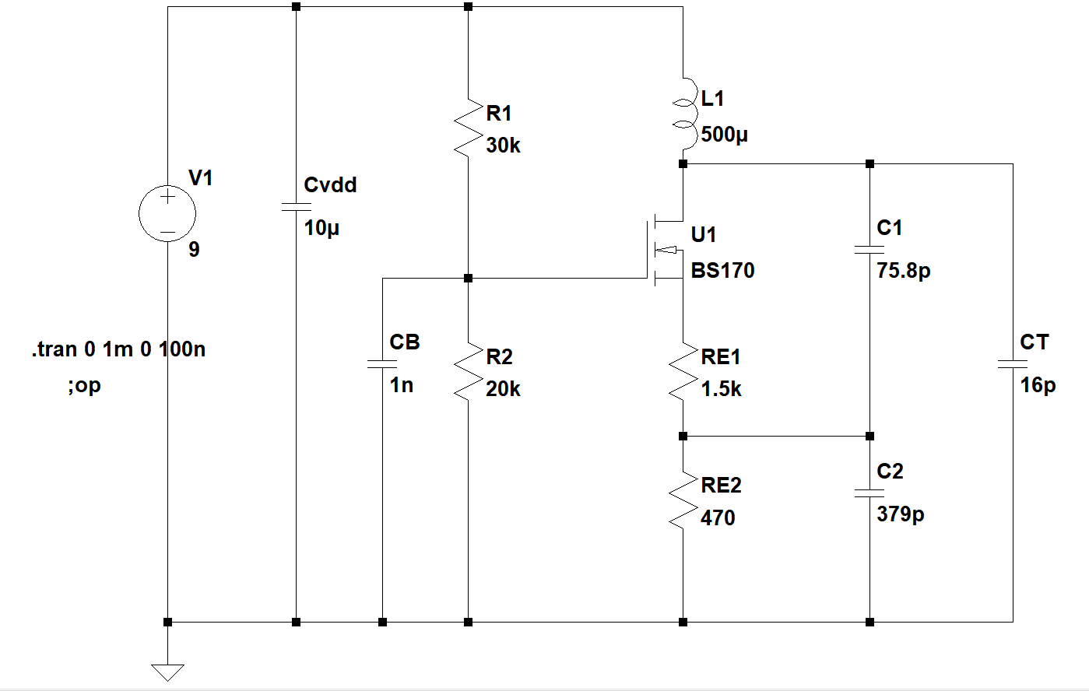

Figure 2: AM modulator LTSpice circuit (extra bypass capacitor not included)

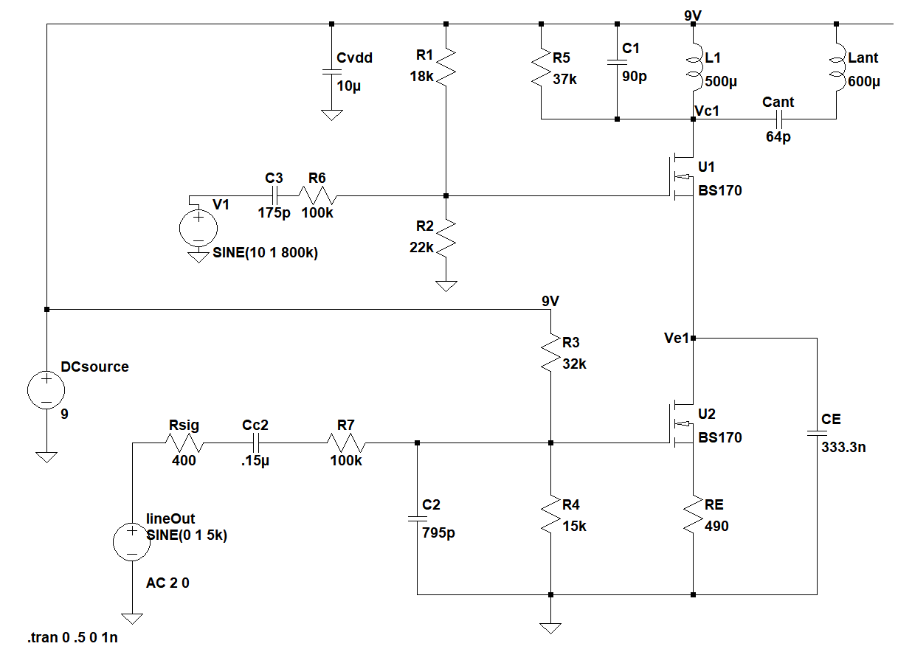

Figure 3: Sound Input Signal Waveform

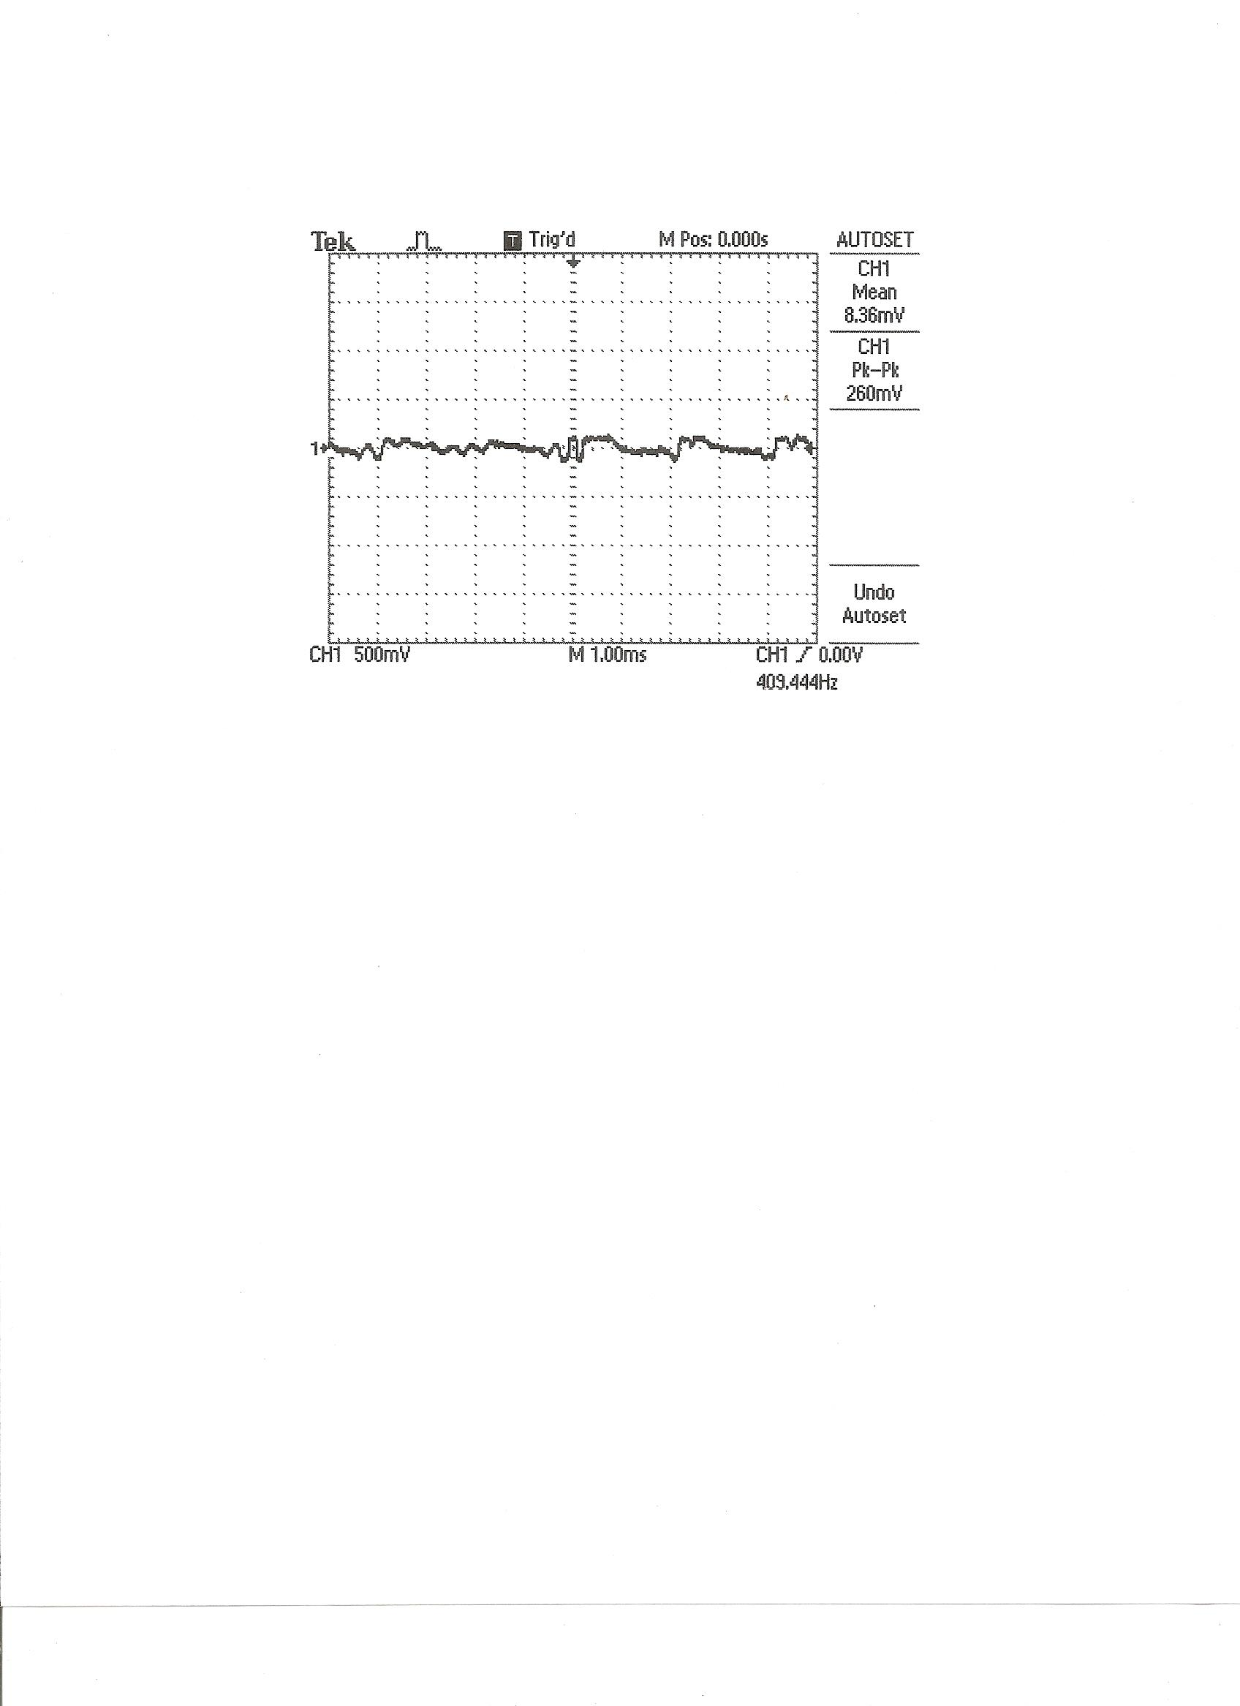

Figure 4: Oscillator Fast Fourier Transform

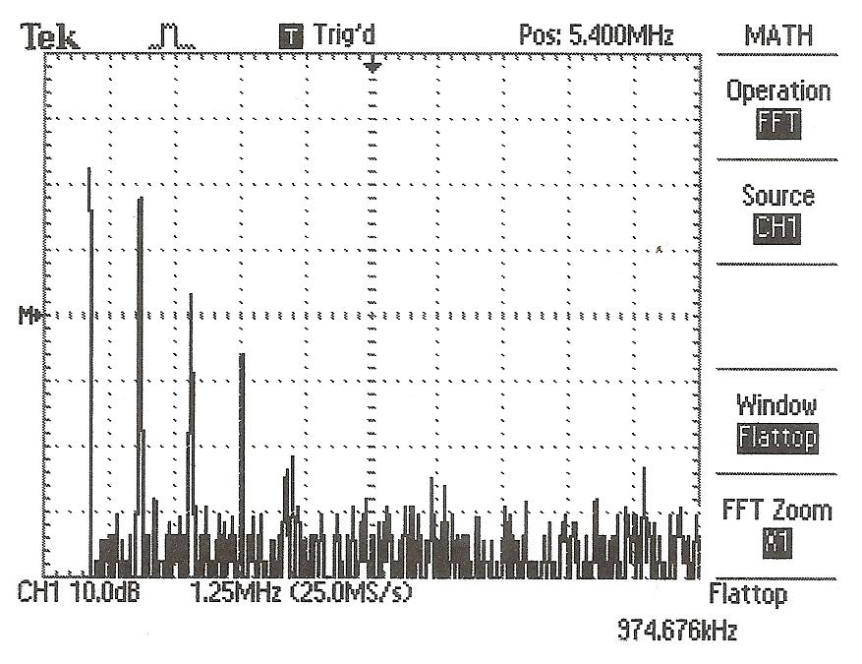

Figure 5: Oscillator Waveform Output

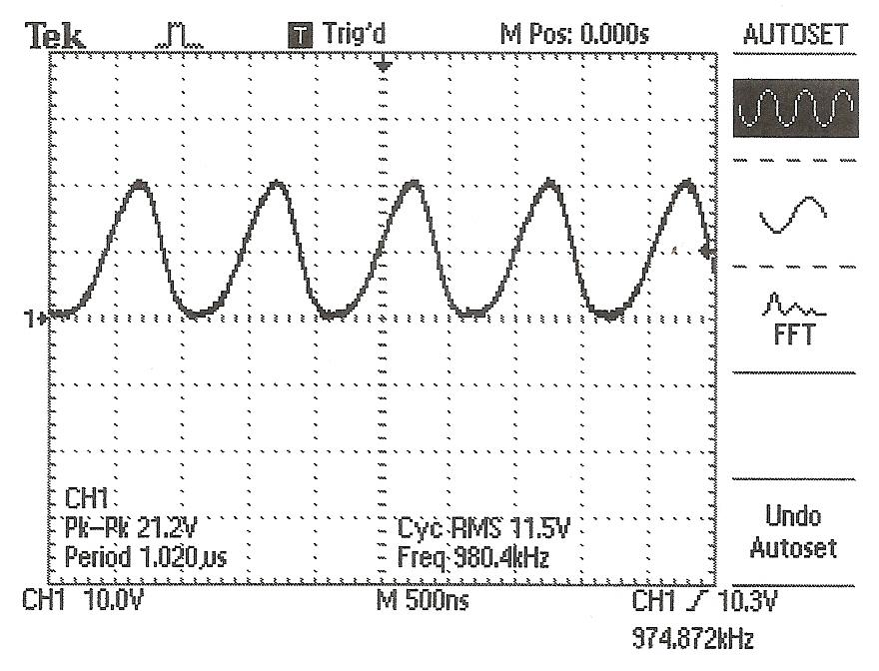

Figure 6: LTSpice Oscillator Waveform Output

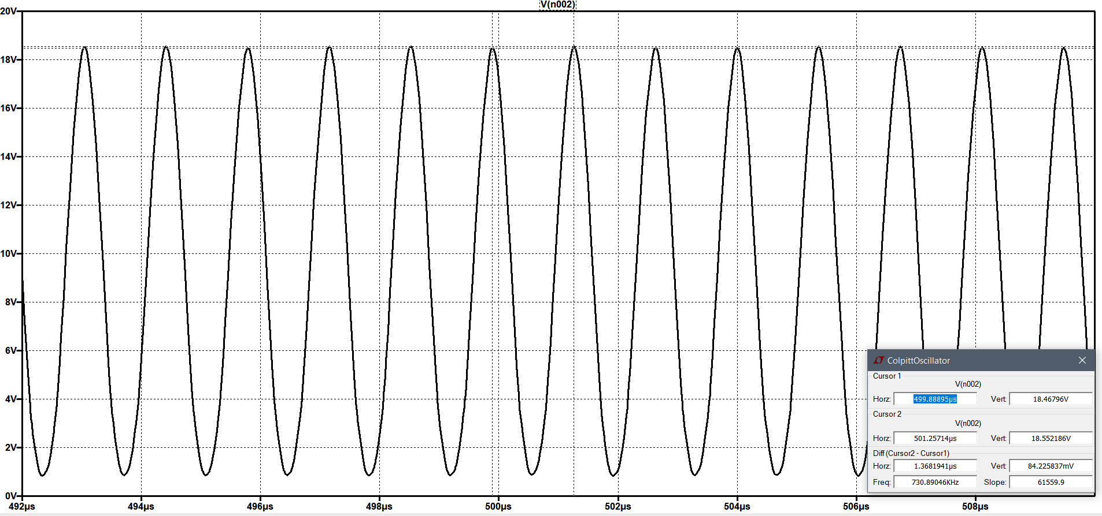

Figure 7: LTSpice Oscillator Waveform Output FFT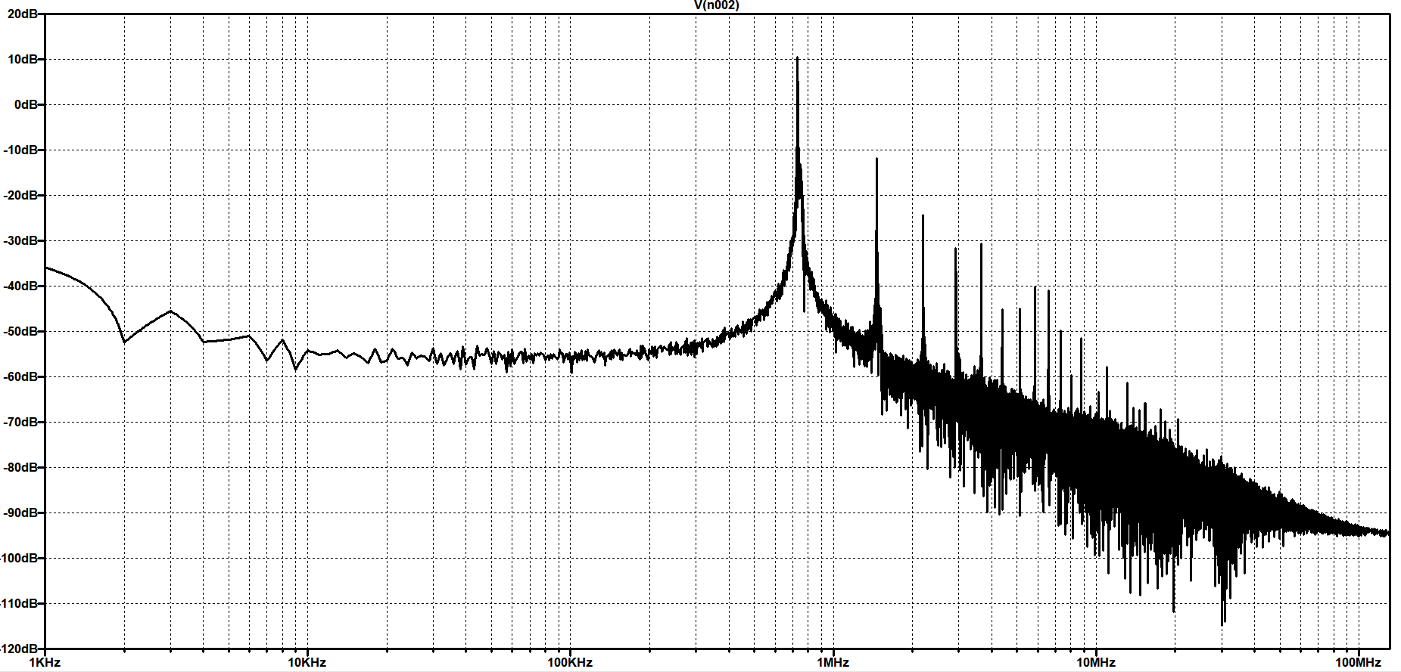

Figure 8: LTSpice Modulator Waveform Output

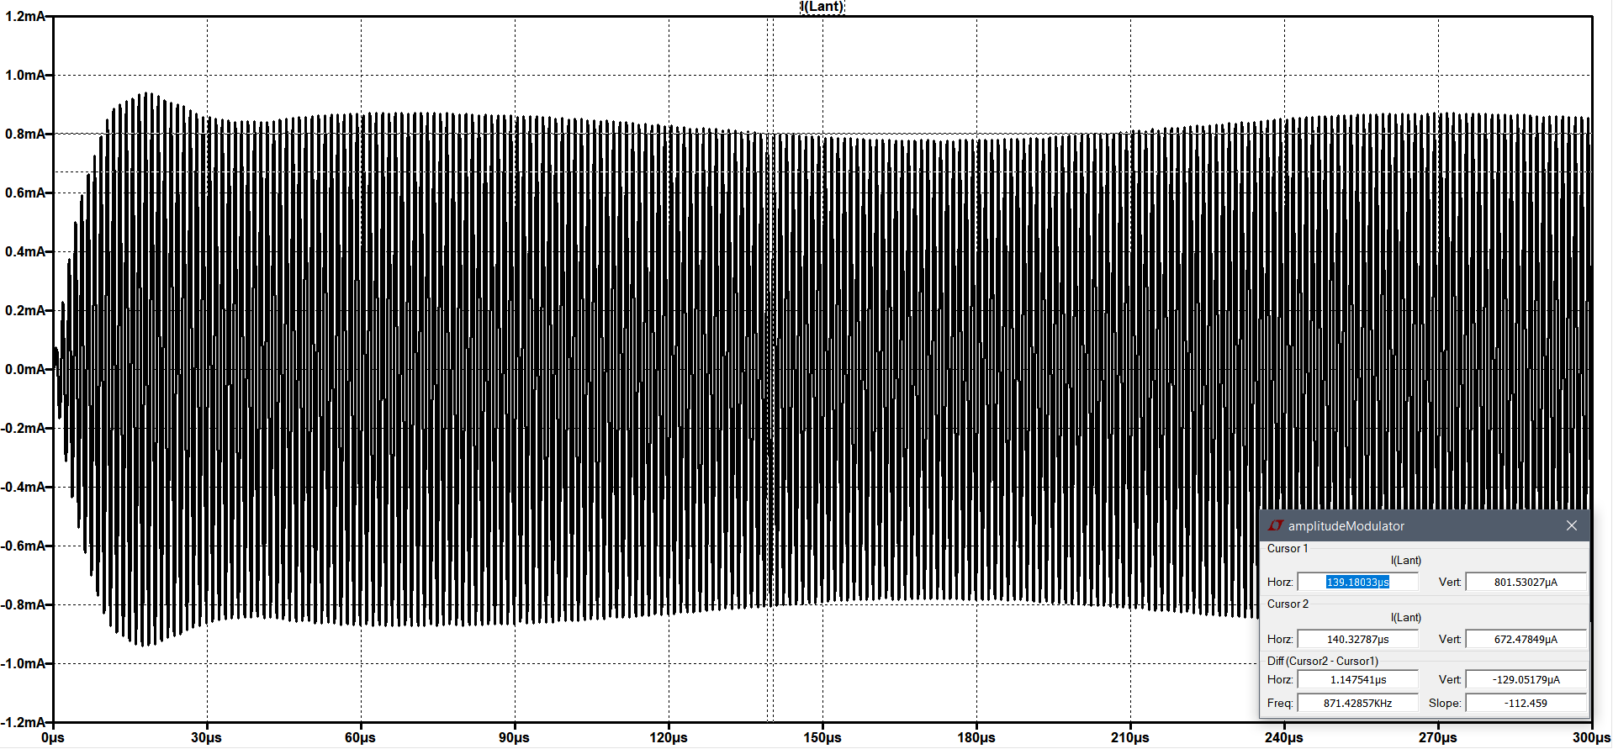

Figure 9: LTSpice Modulator Waveform Output FFT

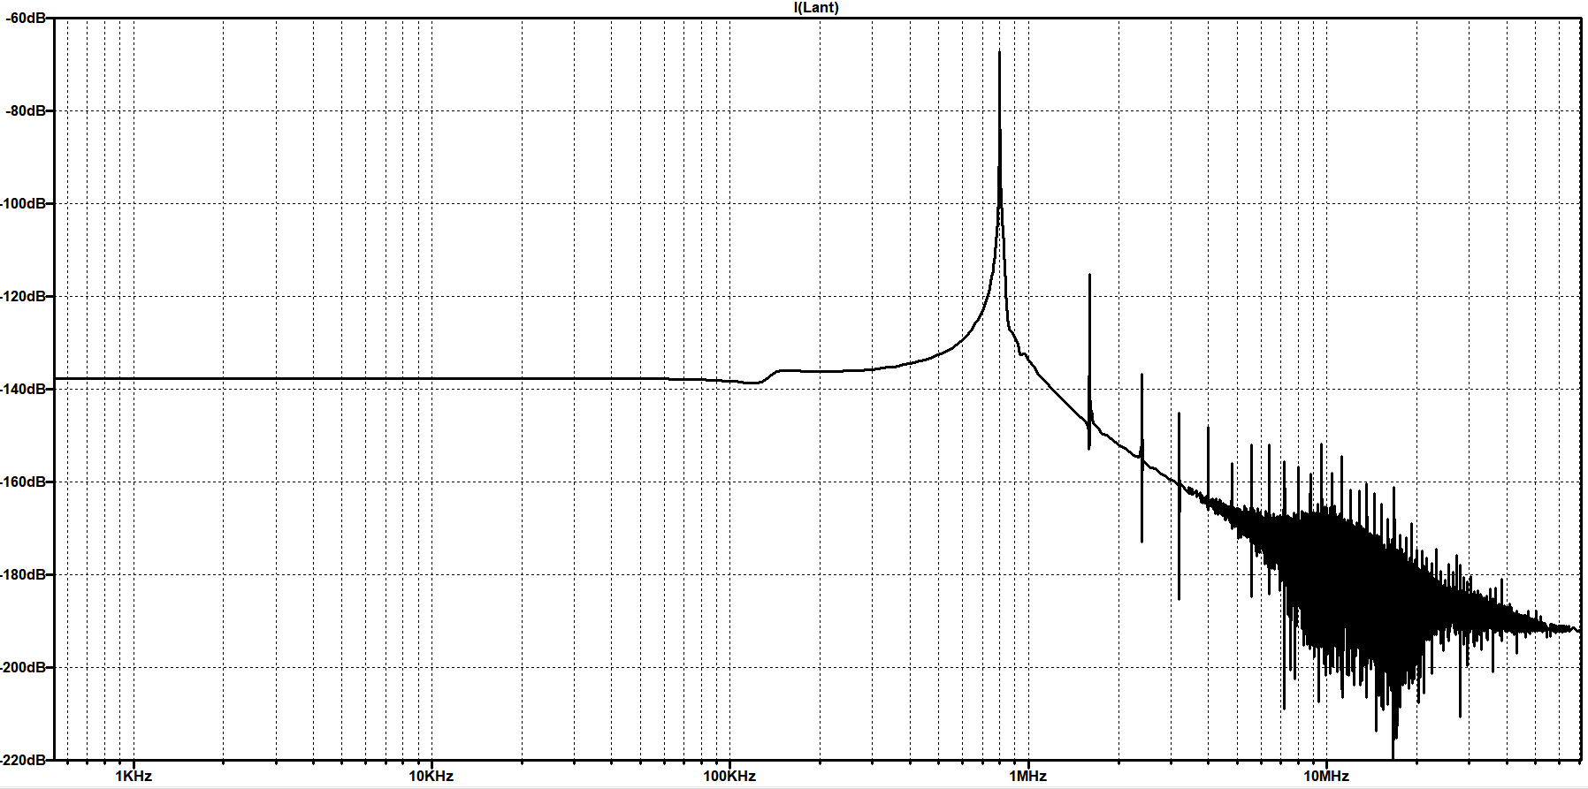

Range of oscillator values from adjusting CT.

Low: 960 kHz

High: 980 kHz

Oscillator inductor value: 490 uH

**DISCUSSION**

The Colpitts oscillator was used to create a carrier frequency. This carrier frequency was responsible for transmitting the audio signal over a frequency that could be detected by an AM receiver. Normally, the AM transmitter will be able to transmit the carrier frequency over extremely long distances, but in this lab’s case, the range from the transmitter to receiver is about one foot, with a maximum range of about 4 feet. For a homemade transmitter, it is fitting that the range is so short because a longer range would begin to interfere with all of the AM receivers in the area, including those used by civilians. This would be an illegal violation of FCC rules, which dictate how radio frequencies can be transmitted.

When we copied our breadboard implementation over to the protoboard, we noticed that the frequency was off by about 40 kHz. This was puzzling, since the values of each of the corresponding parts were nearly identical. Something had been unaccounted for. As we looked over the circuit on the breadboard, we noticed a big difference between the breadboard and the protoboard: the breadboard had a metal plate underneath the entire circuit. We guessed that this was the cause for the decrease in carrier frequency when moving the circuit over to the protoboard. Because the protoboard lacked the extra capacitance, we had to add a small 1 pF capacitor in series with the variable capacitor. This fixed the problem and boosted the frequency of the carrier signal up to the scale that we wanted.

The modulator is responsible for superimposing the audio signal onto the carrier frequency. The audio signal would not be visible on the carrier frequency signal.

In the first build of the modulater, the antenna had an incorrect resonating frequency. We knew this because we saw a very small output signal. To fix this problem, we added a capacitor in parallel with the variable capacitor at the antenna. This allowed the total capacitance impedance to match the inductor impedance at the carrier wave frequency.

Another addition to the original design of the modulator was adding a variable resistor in series with the DC bias resistor on the MOSFET that handled the carrier frequency. We did this because we observed that none of the audio signal was being multiplied to the carrier signal (the output of the drain of the second MOSFET was a DC signal). This was determined to be the result of the incorrectly biased carrier frequency handling MOSFET. This variable resistor allowed us to adjust the bias voltage which is what correctly biased the MOSFET and allowed both the carrier (Figure 5) and audio signals (Figure 3) to be multiplied together (to get Figure 8).

Interesting fact: AM sound quality is worse than FM quality because noise affects the amplitude of a signal more than its frequency. This could be why adding the source capacitor makes the sound clearer (it get rids of the noise). It’s probably also why we have so many coupling capacitors in the circuit.

**CONCLUSION**

Although the AM radio transmitter we built was small and had a low power transmission (it is illegal to transmit at high power levels and interfere with broadcasts) the circuit demonstrates elements of design and planning and used the concepts of an oscillator, multiplier circuit and an interface between two stages. These components allowed us to build out the necessary parts of the circuit and have stages that could work independently from each other, and because of the careful interface design they could also be used together to build a larger circuit. Which could usefully transmit audio signals.

If scaled up, in power not size, the circuit could easily be used to transmit audio to a receiver some distance away. This has applications not only in AM radio but also in radio in other frequency bands where information can be transmitted legally for various purposes including police, forestry, ambulances and amateur radio. While many of these application may use other modes of communication (i.e. CW, Single Side Band, Frequency Modulation or Phase Shift Keying) they all use the basic notion of a radio antenna as shown in use in this circuit.

**APPENDIX**

Figure 10: Colpitts oscillator on protoboard

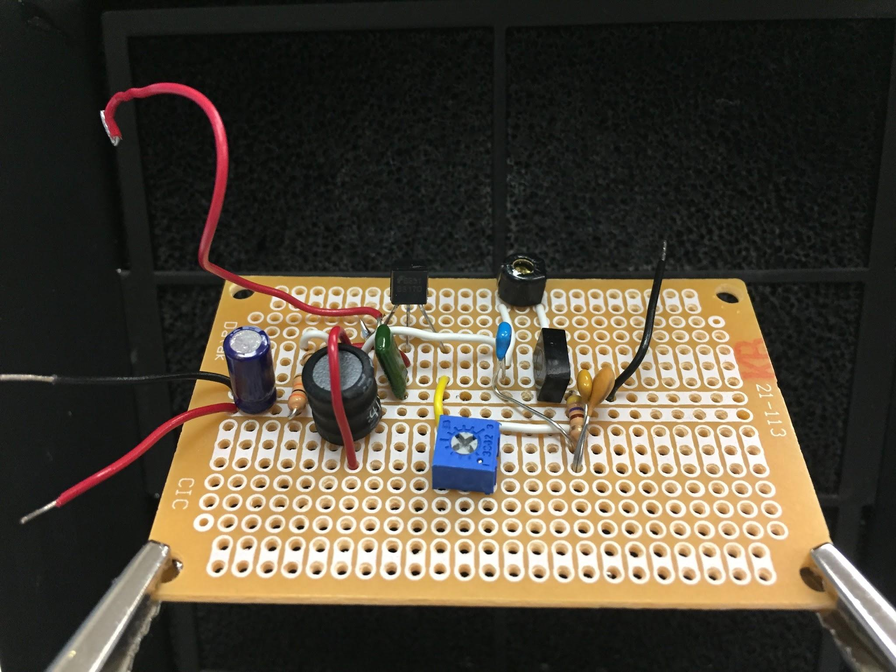

Figure 11: AM modulator on protoboard

